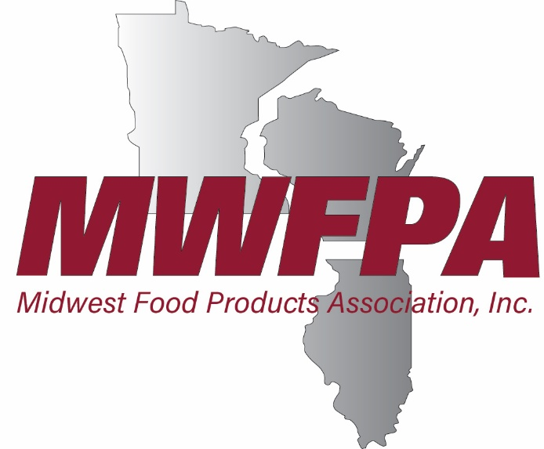
NEWS RELEASE
FOR IMMEDIATE RELEASE
March 18, 2020

Contact:
Jason Culotta, President
608-255-9946
jason.culotta@mwfpa.org

Brian Elliott
Dir. of Communications
608-255-9946
brian.elliott@mwfpa.org

Midwest Food Manufacturers, Trade Associations Ask Clarification, Exemptions in Gathering Law

The Midwest Food Products Association (MWFPA) joined over 60 agribusiness and manufacturing trade associations requesting that state and federal officials clarify exemptions to rules that prevent the gathering of 50 or fewer people until the coronavirus emergency is over.

“Some states have clearly exempted food, beverage, and consumer packaged goods manufacturing facilities (e.g., those manufacturing cleaning supplies, paper goods, personal care products, etc.), while others have not. This lack of uniformity is leading to significant confusion and could further deteriorate if a level of consistency across states and municipalities is not achieved quickly,” the groups stated in a letter sent to state, federal and local officials.

-MORE-

The groups requested that, if necessary, “a federal exemption from gathering bans and curfew be granted for human, animal and pet food manufacturing facilities, as well as facilities that produce essential consumer goods critical to mitigating the spread of COVID-19, so that we can ensure the continued supply of food, essential items, while also ensuring worker safety.”

“This is an unprecedented time for our industry,” said MWFPA President Jason Culotta. “A clear federal exemption will aid in creating continuity across the country and ensure the production of critical items. We also need to ensure that component suppliers, such as pallet and truck seal manufacturers, are included as part of the critical food supply chain.”

The Centers for Disease Control and Prevention (CDC) recently recommended that gatherings be limited to 50 or fewer people, with exemptions for businesses. However, decisions to follow CDC guidance are made at the state and local level. States and localities are currently putting in place gathering restrictions, curfews and other limitations.

-30-

______________________________________________________________________________________________

ABOUT MWFPA
The Midwest Food Products Association represents the business interests of the region’s dynamic food products industry. The association lobbies on legislative and regulatory matters; promotes safe food processing practices; investigates new technologies; funds industry research; and plans industry events. It represents over 100 processing facilities in Wisconsin, Illinois and Minnesota.

