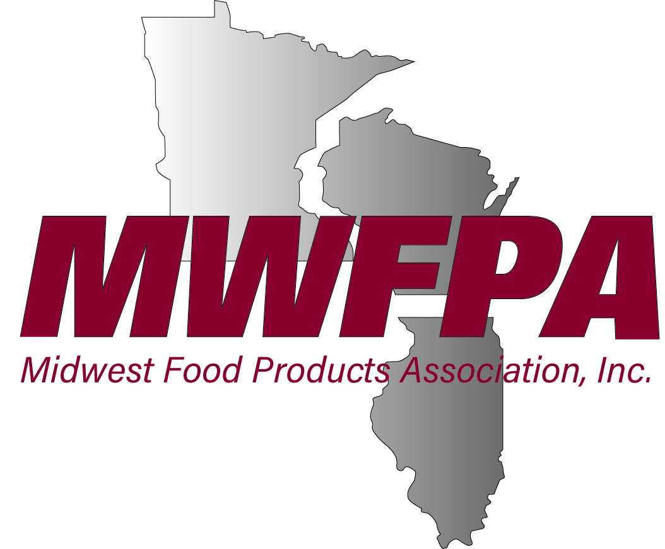
NEWS RELEASE
FOR IMMEDIATE RELEASE
January 17, 2020

Contact:
Jason Culotta, President
608-255-9946
jason.culotta@mwfpa.org

Brian Elliott
Dir. of Communications
608-255-9946
brian.elliott@mwfpa.org

Bonduelle’s Anderson Elected Chair of Food Products Board

The Midwest Food Products Association (MWFPA), a trade group which represents food manufacturing companies and their allied industries on a variety of food related issues in Illinois, Minnesota and Wisconsin, announced that Rob Anderson, Vice President of Ontario, Alberta & USA Operations with Bonduelle North America, has been appointed chairman of the organization’s board of directors for 2020.

Anderson is responsible for nine company facilities in Ontario, Alberta, Wisconsin, Pennsylvania and New York. Prior to Bonduelle, Anderson also worked for Green Giant, Strathroy Foods and Carriere Foods. Industry posts include being a member of the board of directors at Food and Beverage Ontario, past president of the Ontario Fruit and Vegetable Processors Association and the Ontario Fruit and Vegetable Processors Association. He has served on MWFPA’s board of directors since 2013.

-MORE-

As chairman, Anderson will assume leadership of MWFPA’s governing body and will preside over quarterly meetings of the Association’s board of directors. That body adopts policies and provides strategic guidance and oversight for the organization.

“I look forward to helping MWFPA further enhance its position as one of the leading voices in the food manufacturing industry” said Anderson. “To serve as board chair is an honor and privilege. I look forward to working with its staff at who are committed to the service of our membership.”

MWFPA President Jason Culotta stated, “Rob has worked on behalf of food manufacturers for many years in both the United States and Canada. He has a solid industry background. I am confident he will provide strong leadership as we work together with our membership to improve the Association and the regulatory environment which impacts manufacturing in the Midwest.”

Several changes and additions to the MWFPA Board of Directors were announced at the annual meeting held during the association’s convention in Wisconsin Dells, Wisconsin December 3-5, 2019:

Mark Enter (Lakeside Foods), Bob Goeres (Lodi Canning Company), Chris Jones (McCain Foods) and Ken Sevcik (Faribualt Foods Inc.) agreed to serve additional three-year board terms.

Mark Zblewski (Del Monte Foods) replaced Jim Knetsch (Del Monte Foods) who stepped down from the Board in August 2019.

The Association’s officers for 2020 are:

Chair: Rob Anderson, Bounduelle USA
Vice-Chair: Mark Enter, Lakeside Foods
Secretary/Treasurer: Tom Kwak, Chippewa Valley Bean
Past Chair: Jon Brekken, Seneca Foods Corporation.

In addition to the above officers, the MWFPA Board of Directors includes:

-MORE-

Dean Becker - A&K Development
Jeff Griep - B&G Foods
Brad Krings - Bush Brothers & Co.
Mark Zblewski - Del Monte Foods
Ken Sevcik - Faribault Foods
Ryan Downs - GLK Foods
Bob Goeres - Lodi Canning Company
Steve Hughes - Lyco Manufacturing
Chris Jones - McCain Foods USA
Kip Guyon - Pinnacle Foods

-30-

______________________________________________________________________________________________
The Midwest Food Products Association represents the business interests of the region’s dynamic food products industry. The association lobbies on legislative and regulatory matters; promotes safe food processing practices; investigates new technologies; funds industry research; and plans industry events. It represents over 100 processing facilities in Wisconsin, Illinois and Minnesota.

